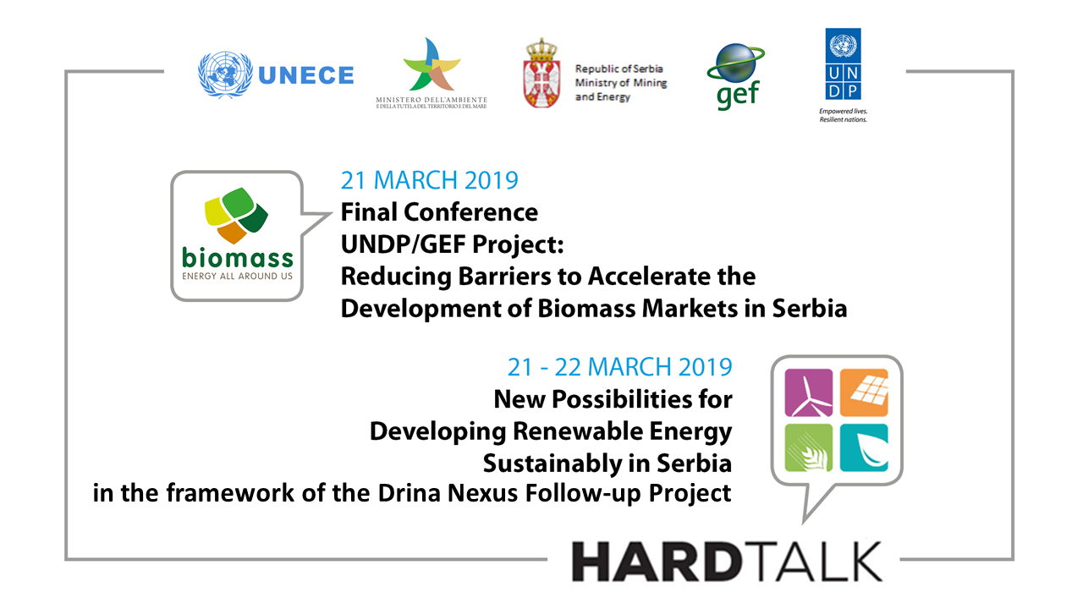

DRAFT AGENDA (12 February 2019)
21-22 March 2019

Thursday, 21 March 2019

Day 1 – UNDP/GEF Project Final Conference

Participation is by invitation only
Venue: Serbian Chamber of Commerce, Resavska 13-15, 11000 Belgrade

09:00-09:30 Welcome Coffee & Registration

09:30-10:30 OPENING SESSION
- Welcome addresses by:
  - Minister/Deputy Minister, Ministry of Mining & Energy, Republic of Serbia
  - Mr Salvatore D’Angelo, Ministry for Environment, Land and Sea, Italy
  - Mrs Steliana Nedera, UNDP RR
  - Mr Gianluca Sambucini, Secretary of the Group of Experts on Renewable Energy, Sustainable Energy Division, UNECE
- Scene setting presentation of Discussion Paper “Key Recommendations for facilitating private sector investments in sustainable renewable energy projects”, Ms Emily Koulouvaris, Managing Director, and Mr Vassilis Triantafyllos, Regulatory Expert, Revelle Group

10:30-11:00 COFFEE BREAK

11:00-13:00 Session 1: Reducing Barriers to Accelerate Development of Biomass Markets in Serbia
- Co-moderators: Representative of Ministry of Mining & Energy, Republic of Serbia, UNDP
Presentations
- Introduction, Mr Milos Banjac, Assistant Minister and National Project Director, Ministry of Mining and Energy
- Results of UNDP-GEF project “Reducing barriers to accelerate development of biomass markets in Serbia”, Ms Maja Matejić, Energy Portfolio Manager, UNDP
- Name of presentation #2
- Name of presentation #3
Debate
- Key stakeholders – their views on the findings and recommendations for the development of biomass markets in Serbia and investment opportunities
- Discussion and input to the Hard Talk Recommendations

13:00-14:00 lunch break

Thursday, 21 March 2019

HARDTALK

Day 1- Targets and Non-hydro

Participation is by invitation only

14:00-15:30 Session 2A: Non-hydro renewable energy barriers and solution pathways – Institutional, policy and regulatory barriers
Co-moderators:
- Local representative & Mr Vassilis Triantafyllos, Revelle Group
Interventions
- Energy Community – RES Directive and requirements for new targets
- IFIs – Financing RES requirements
- UNECE – Water-Energy-Food Nexus considerations for energy planning
- Debate will focus on barriers of a wider nature – e.g. the support scheme for non-hydro renewables, unbundling in the sector and developing an operating wholesale market, etc. including the following risks as detailed in Discussion Paper:
  - Power Market risk
  - Social Acceptance risk
  - Financial Sector risk
  - Political risk
  - Currency / Macroeconomic Risk

15:30 –16:00 Coffee Break

16:00-16:50 Session 2B: Non-hydro renewable energy barriers and solution pathways – project-specific barriers
Co-moderators:
- Local representative & Ms Emily Koulouvaris, Revelle Group
Interventions / Debate
- Interventions targeting risks in Discussion Paper:
  - Resource & Technology risk
  - Permits risk
  - Grid/transmission risk
  - Counterparty risk
- Debate will focus on barriers of a project-specific nature – e.g. bankability issues (counterparty risk, PPAs, access to financing) and project development issues (grid management and access, permitting, land zoning, etc.)
- A review of the current project pipeline under development will also be undertaken

16:50-17:00 SUMMARY DAY 1
- Closing remarks by UNECE & Ministry

Friday, 22 March 2019

HARDTALK

Day 2 (Half-day)

(to include key water management, rural development/agriculture and environment policy stakeholders)

Participation is by invitation only
Venue: Serbian Chamber of Commerce, Resavska 13-15, 11000 Belgrade

09:30-10:30 Session 3: Sustainable development of renewable energy sources, including hydro, applying the Water-Energy-Food-Ecosystem Nexus
Co-moderators:
- Local representative & Ms Annukka Lipponen, Environmental Affairs Officer, UNECE
Presentations
- RES development challenges and possible national policies - Ministry of Mining & Energy, Republic of Serbia
- Intervention on intersectoral (nexus) aspects including the environmental and water resource considerations, Ministry of Agriculture, Forestry and Water Economy/Ministry of Environmental Protection, Republic of Serbia
- The nexus and transboundary dimensions of renewable energy development: trade-offs and synergies- Ms Lucia De Strasser, UNECE Consultant

10:30-11:00 CoffeeBreak

11:00-12:00 BREAK-OUT GROUPS
Breakout groups
- Three Breakout groups to discuss the inter-sectoral synergies and trade-offs related to the expansion of different RE technologies :
  - Group 1- Hydropower
  - Group 2- Biomass
  - Group 3 - Wind/solar
Discussions should aim at defining a “nexus criteria” for new project development, taking into account good practices and ultimately result in “investment guidelines” on how to make RES investments more sustainable using the nexus approach. Project pipelines can be discussed as well as concrete examples from private sector companies.

Importantly, these discussions should address intersectoral synergies and trade-offs to better develop RES and improve its acceptance (e.g. co-benefits of flow regulation for flood protection etc., links to forestry and agriculture development for biomass, advantage of basin management to reduce impacts on hydro, etc.).

12:00-12:30 session 4: summary and conclusions days 1& 2
- Takeaways from Breakout Sessions as presented by each group’s rapporteur
- Technical Summary on input received from participants on revisions to the Discussion Paper, Revelle Group
- Closing remarks UNDP, UNECE & Ministry
END OF HARD TALK AND SESSION ON BIOMASS

12:30-13:30 Adopting a nexus approach to Renewable Energy development in the Drina Basin: Consultation meeting on proposed analytical work
This session will provide input to a project funded by the Austrian Development Agency on “Promoting the Sustainable Management of Natural Resources in Southeastern Europe, through the use of Nexus approach”. The project will feature the modelling of renewable energy expansion in the Drina river basin and help to quantify some of benefits. The participants will be consulted on the scoping and objectives of the modelling exercise in order to ensure its policy relevance.

13:30 END OF MEETING

13:30 – 14:30 lunch

